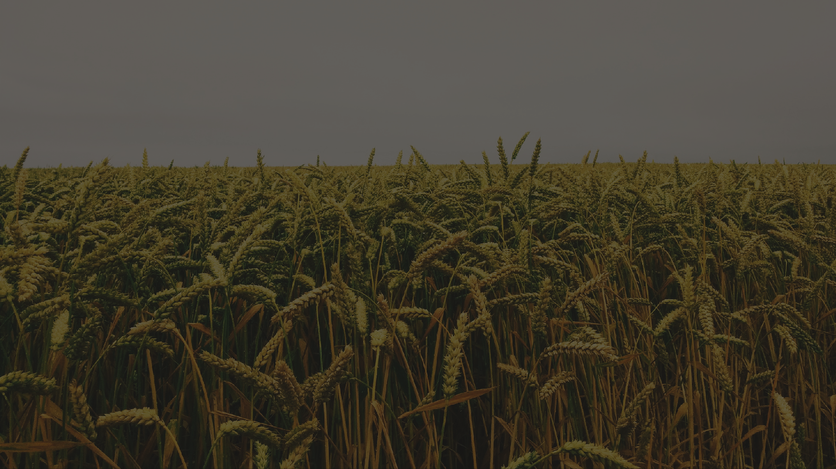



Market Research

Agriculture mechanization and Agro-Food Industrial transformation in Nigeria.

Prepared by Koinonia Ventures Limited for The Italian Trade Agency

JULY 2023


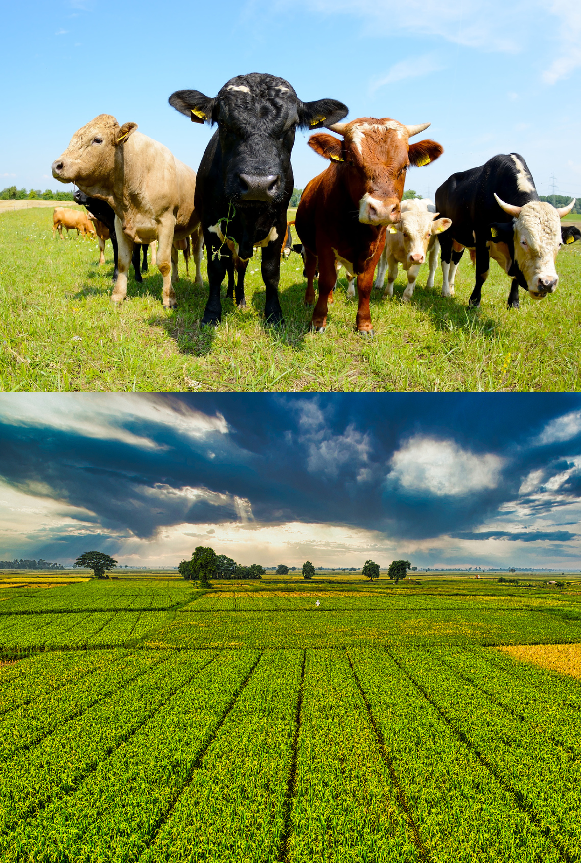
Study outline
01
02
03
04
05
06
07
08
Project Mandate and Agriculture in f igures Methodology
Market Dynamics and Research Concept Opportunities and Potentials
Operations and Growth Strategies Risk and Mitigation Strategy
Conclusion

List of Appendices.


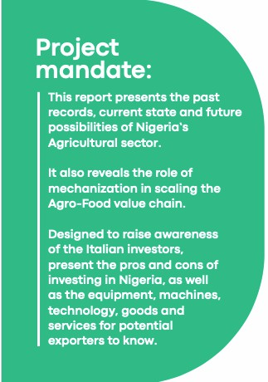
geria's Agricultural sector in figures.
Nigeria’ s total agricultural import sums to
9 . 2 B EUR ( $ 10 B) in 2022 - mainly wheat, r ice, poultry & f ish); total agricultural export 707 M EUR ( $ 771 M) - mainly cocoa beans, cashew
nuts, sesame seeds.
The mechanization rate in Nigeria is
0 . 27 horsepower/ hectare, below FAO’ s
recommendation of 1 . 5 horsepower/ hectare. That is, farmers have 6 tractors for every 10 , 000
hectares of arable land.


01
From 1960 to 1969 , Nigeria' s Agricultural sector accounted for 57 . 0 % of GDP and
64 . 5 % of export earnings. Between 2016 and 2021 , i t declined to 23 . 5 % of GDP and 5 . 1 %
of export earnings.
The sector engages 35 . 21 % of total employment. Crop production, at 19 . 48 % in Q 1 2023 , is the best performing Agricultural sub- sector with highest value chain
potentials. across agro- food industry
02

03

04

Methodology
Data represented in this market research are up-to-date (2017 and 2023); factual (obtained from and compared with reliable sources); and graphically presented for the purpose of informing investment in the sector.
Sources include: the Federal Ministry of Agriculture and Rural Development, Private Agro-allied companies, Nigeria Bureau of Statistics, Association of Practicing Exporters, FAO, AfDB, PwC, World Bank, and OEC





Desk Research
Internal and external desk research were conducted by the team to obtain the data used, guide the interviews conducted and prioritize the database & policy banks explored.

Stakeholders' mapping & Interviews
A balanced mix of stakeholders from the aforementioned were consulted to guide the report outcome. The selection was based on their level of involvement, interests & availability.

Report drafting & final presentation
This report is presented in a concise, clear and organised format highlighting figures, topics and other findings relevant for potential Italian investors to consider.

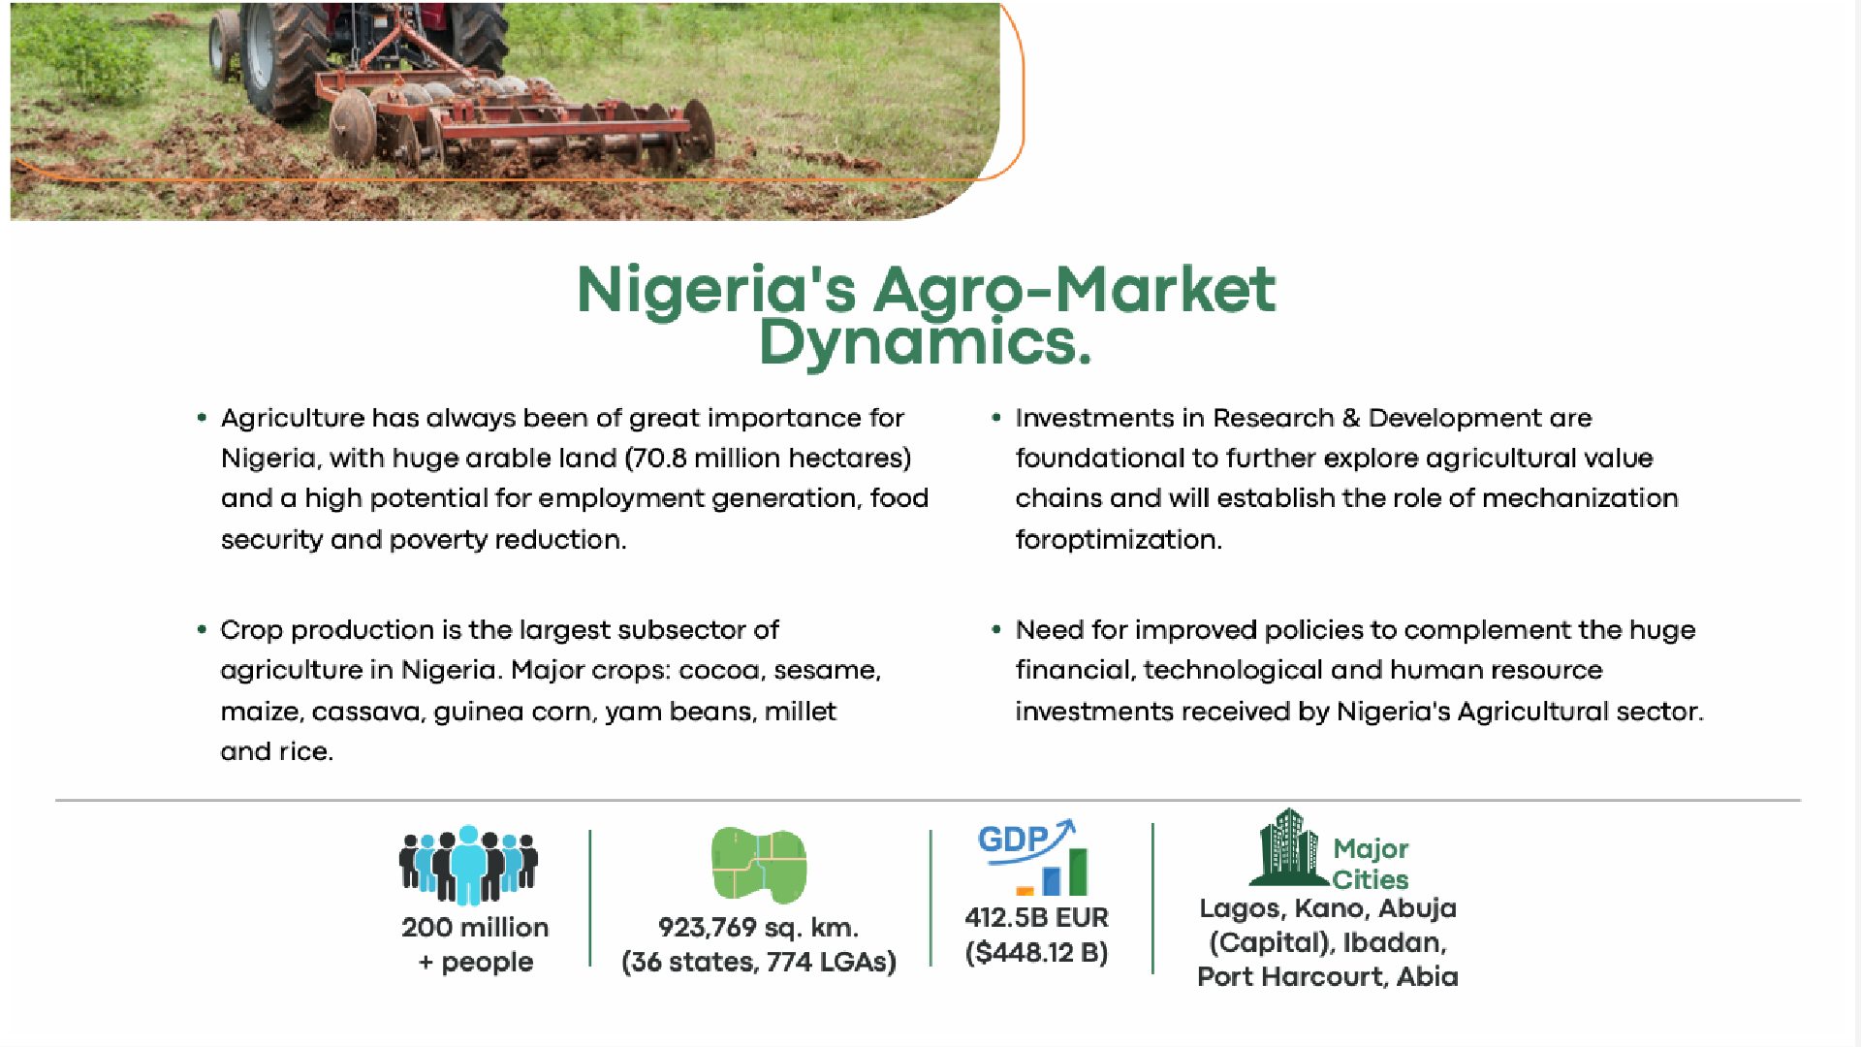

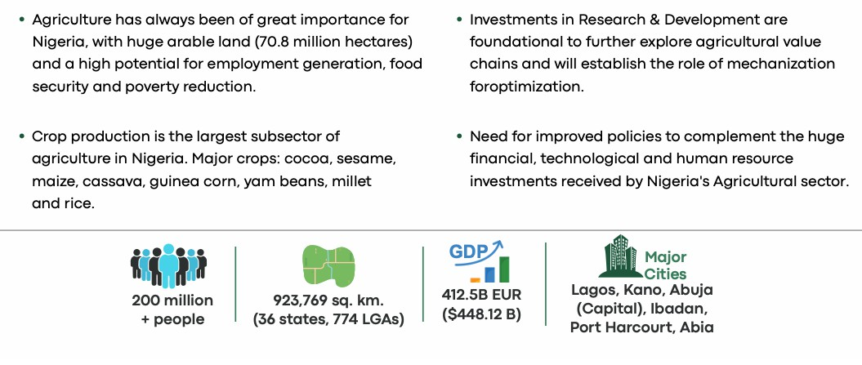

convert to Infographs
- Agriculture's contribution to GDP per sector (Crop production - 90%, livestock, forestry and fishing comprising the remaining 10%.)

- 2016 and 2018, Nigeria's Import and Export expenditure - N0.53 trillion from export and spent N2.39 trillion import.

- 65% of the total cultivated area -
Cassava, yam, maize, sorghum, rice and millet.

Nigeria's Agricultural sector
Agriculture has proven to be the most valuable contributor to Nigeria’s economic growth. The Nigerian government has been supporting the agricultural industry with a number of policies.

Nigeria has a very high potential for improving uncultivated land and exploring agro-food processing, which translates into veritable opportunities for technology, mechanization, packaging/labelling and export growth.

Of Nigeria's vast land area (98.3 million hectares), 74 million hectares arable but barely half is utilized efficiently for agriculture due to lack of mechanization.

The economic potentials are enormous, with high revenue yields from both domestic value addition and derived income as well as revenues for the government. With improved varieties and production techniques, production is anticipated to increase.

Top Agricultural export
highlight of Nigeria’s top-performing agricultural export (2021 - 2022)


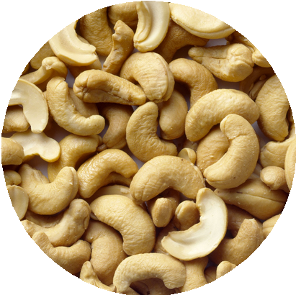
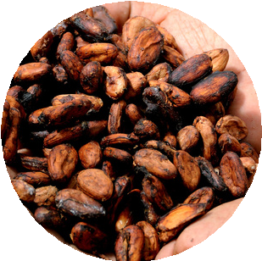
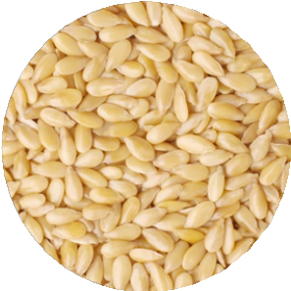

Cocoa - 715 . 9 M EUR ( US$ 779 M) in 2021
In different form ( beans, powder, fermented, etc.) accounted for 0 . 8 % of the total exports and 30 % of agricultural export in Nigeria. 340 , 000 tonnes
exported annually. N 114 . 1 billion in H 1 2023 .

Sesame seeds - 643 . 3 M EUR ( US$ 700 M) in 2022
Second most- lucrative after cocoa, Nigeria is the sixth- largest exporter in the world. Accounts for 0 . 6 % of total exports, 25 % of the country’ s
agricultural export, about 490 , 000 tonnes exported annually.

Cashew - 229 . 7 M EUR ( US$ 250 M) in 2022
Accounts for 0 . 5 % of total export and 10 % of the country’ s agricultural export. 300 , 000 metric tons in 2022 , $ 500 million projection by 2023 .

Ginger- 10 . 7 M EUR ( $ 12 M) in 2021
Nigeria exported $ 12 million worth of ginger in 2021 ( 523 , 000 metric tonnes) representing 14 per cent of global supply.

Top Agricultural production
highlight of Nigeria’s top-performing agricultural products (2019 - 2022)
Cassava - 59 M tonnes


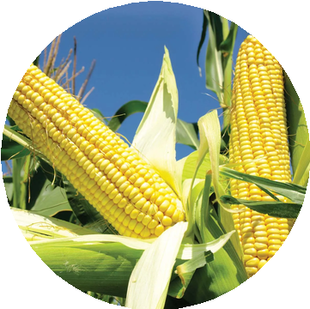

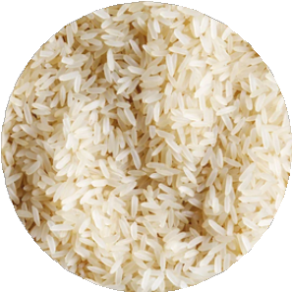
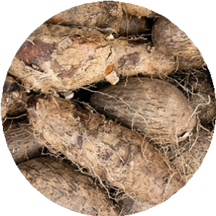
Nigeria grows over 50 % of the world’ s cassava ( 4 . 5 million farmers involved, covers 3 . 8 million hectares and produces 60 million tonnes annually.
Yam - 50 M tonnes produced in 2019
West Africa accounts for more than 90 per cent of global yam production. Nigeria contributed about 67 per cent in 2020 .
Maize - 11 M tonnes

11 million metric tonnes produced annually, only 1 , 412 tonnes exported in 2019 . Mostly for local consumption, poultry feed and beverages.
Rice - 8 . 3 M tonnes in 2021

Nigeria leads in r ice production in West Africa though still very import
dependent. The average yield is approximately 1 . 8 metric tonnes per hectare.

Sorghum - 6 . 1 M tonnes in 2020

Nigeria is the leading sorghum producer in Africa and second- highest
producer in the world with productivity of 1 . 23 tonnes per hectare and an annual production of 6 . 7 million metric tonnes.

Top livestock production
highlight of Nigeria’s top-performing livestock (2021 - 2022)



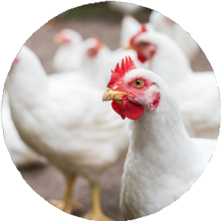


Poultry - 180 million birds as at 2021
Nigeria has the largest annual egg production and second largest chicken population in
Africa. Produces 300 million tons of meat and 650 million tons of eggs but only meets 30 % of the demand for chicken eggs and meat. 4 in 10 Nigerians ( 42 %) are into small scale to
medium scale poultry farming.

Goat - 76 . 3 million as at 2021
The most traded l ivestock in the Nigerian l ivestock market and second most
important suppliers of meat protein. Mainly produced by smallholder farmers in low input, low yielding systems.

Sheep - 48 . 6 million as at 2021
Sheep is in high demand in Nigeria, raised for meat or wool production. Though mostly resistant to diseases, they demand constant attention.

Cattle - 21 . 6 million as at 2021
Kept for their milk, meat, and hides. Cattle supplies 45 percent of total meat
consumed in Nigeria, Used as a source of farm power in animal traction and cow dung for bio fuel and soil fertility.

Livestock industry accounts for 10% of the Nigeria's agricultural GDP.
Nigeria is still import-dependent to meet her high rate of livestock/protein demands. High health requirements and the under-exploitation of the sector by the mostly small-scale farmers remains a challenge.



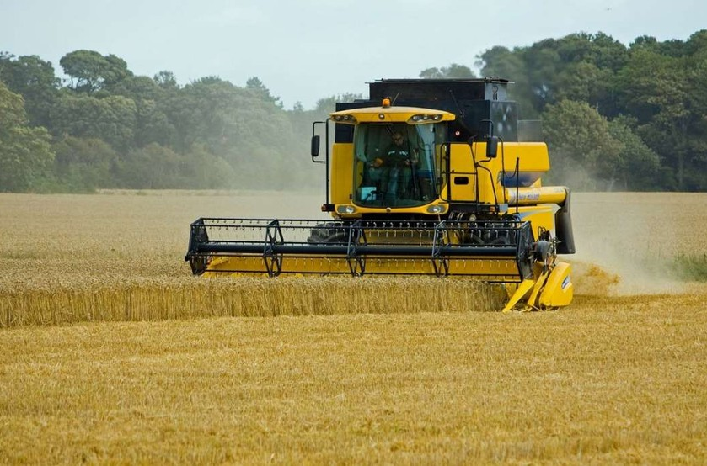

Mechanization in Nigeria's Agricultural sectors

01
Mechanization in Nigeria is low but has a growing demand. 0 . 2 horsepower/ hectare, that is 6 tractors per 10 , 000 hectares .

02
Private- sector machinery hiring service providers have more efficiently met smallholder demand.

03
No standalone policies govern or shape Agricultural mechanization in Nigeria, the government ( state and federal) explores various initiatives and programs, as well as leverages public- private partnerships by introducing subsidies, interest- free loans, and tractor distribution.

04
Beyond subsidies, the government through duties exemptions ( between
5 %- 35 %), is aiming to reduce transaction costs for agricultural machines to improve mechanization . The government is gradually introducing regulatory measures, testing and certifying machines and operators.

05
A significant portion of Agricultural produces from Nigeria is by subsistence smallholder farmers cultivating between 1 - 2 hectares , more than half goes to waste annually due to inadequate post- harvest management, which can be
reduced by improved mechanization.

Types of mechanization in Nigeria's Agricultural sectors

Human Powered Sources
Human Powered Sources: Involves use of hand tools and manually operated equipment that rely on human power. Majority of agricultural activities are carried out using traditional tools like hoes and cutlasses. A significant majority, 90% of Nigeria's agricultural activities, are carried out using hand tools.

Animal Power based Mechanization: second level of mechanization, caters to about 7% agricultural activities in Nigeria. Animals such as horses, oxen, mules, donkeys, and bulls are utilized to drive primary tillage implements and transport farm produce. Draught animals can accomplish work up to 5 to 20 times more than human labour. Report shows that involve the use of animal-drawn tools.

Animal Power based Mechanization:

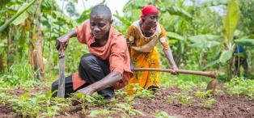
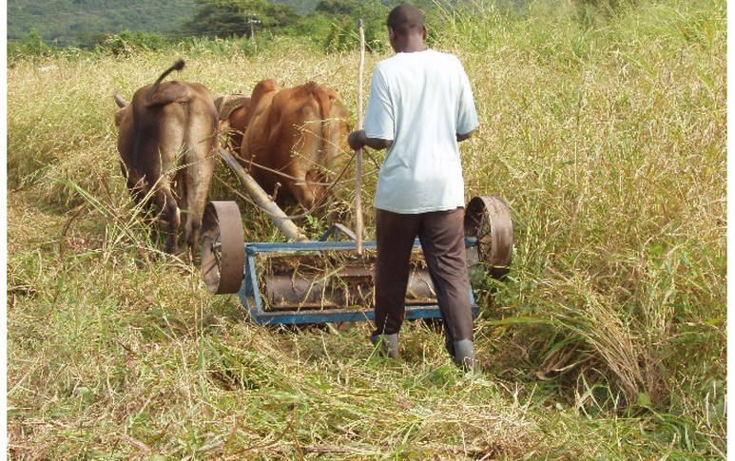
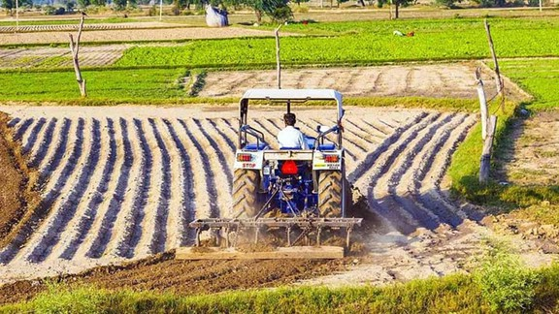

Engine Powered Sources
Engine Powered Machines: This is the highest level of mechanization, only 3% of agricultural activities utilize engine-powered technology, where machines are powered by sources such as fossil fuels, wind, or solar energy. A farmer dependent on agricultural mechanization can provide enough food to feed up to fifty people, while a farmer using draught animal power can only feed six people.

State of mechanization in Nigeria's Agricultural sectors

The agricultural mechanization level in Nigeria is one of the lowest in the World. Nigeria's tractor density is significantly lower compared to other countries like Algeria and South Africa.

Demand for mechanization is high while the supply is low, only ten tractors are available per 100 hectares of farmland in Nigeria as compared to 241 tractors per hectare in Indonesia.

On average, smallholder farmers in Nigeria manage between 0.1 and 4.99 hectares, mostly traditional and relying on crude implements such as hoes, machetes, and pickaxes.

By international standards, a farm that is less than 10 hectares is classified as small-scale. Smallholder farmers are responsible for over 90% of the total food output in Nigeria, contributing around 45% of the GDP and employing two-thirds of the total labour force, providing livelihoods for over 90% of the rural population.

4% of tractor usage covers 7% of cultivated areas and 24% of animal traction usage covers 25% of cultivated areas in Nigerian farm households. Over 2 million farmers across 19 states in Nigeria actively employ animal traction in their agricultural practices but are not utilized to their full potential due to limited access and knowledge.

to add infographs and images

State of mechanization in Nigeria's Agricultural sectors

Cumulatively less than 10% of agricultural production in Nigeria is mechanized, mostly handled by traditional producers (except for wheat)

Between 2010 and 2013, approximately 1000 tractors were imported annually (government - 900 and private sector - 100)

Poor maintenance culture of machines. In 2015, 928 governments and 422 privately owned functional tractors were recorded.

The private sector remains an efficient provider, particularly via the farmer-to-farmer model, small-scale retailers sell 10–30 tractors yearly (new, refurbished, or a combination of both).

Used tractors often provide affordable alternatives to new tractors, with spare parts and repair services available in local markets.

Nigeria needs at least one million tractors to achieve the mechanisation of the agricultural sector.

In 2022, only 7,000 functional tractors providing services to Nigerian farmers. Smallholder farmers account for approximately 90% of the country's yearly produce, in 2020, over 100,000 smallholder farmers made requests for tractors.

Plateau State bought 300 tractors for farmers via the Agricultural services and training center for farmers for a cultivable land area of 70,000,000 hectares.
to add infographs and images


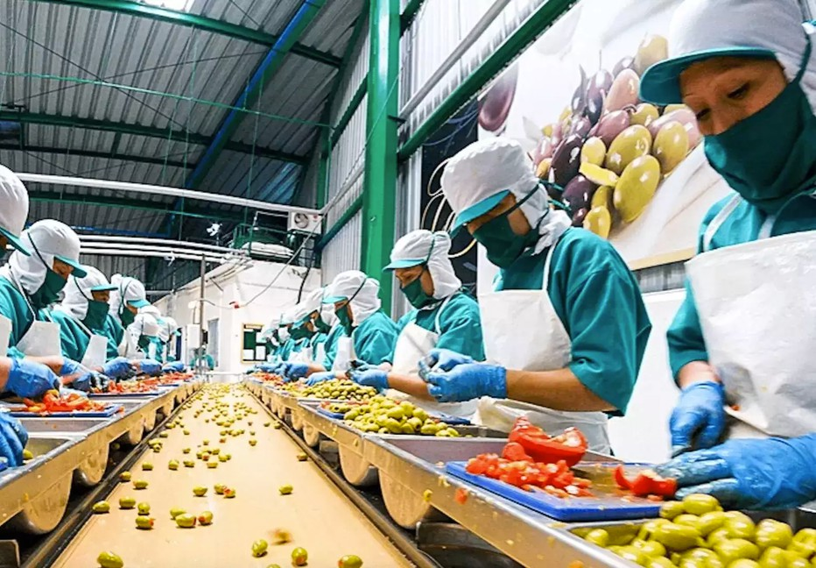

Mechanization in Nigeria's Agro-Food industry

With more mechanization, there will be increased Agricultural production in Nigeria

Mechanization of agriculture has solved food scarcity problems in many countries. For example, only about 3 per cent of the American population is engaged in farming, and one American farmer produces enough food to feed thousands; a family can manage up to 1200 hectares of farmland

Poor mechanization has led to the decline in the production of key commodities like groundnut, palm oil, cocoa, and cotton has resulted in the loss of an estimated USD 10 billion in annual export opportunities.

Unfortunately, numerous challenges hinder the country's progress in transitioning to modern agricultural implements.

Challenges of Agro-Food sector in Nigeria
Low agricultural mechanization,
under-utilization and inconsistency of farm power, Lack of collective drive for agro-processing in Nigeria

State of mechanization in Nigeria's Agro-Food sectors

Agro-Food mechanisation is central to economic diversification or food security in Nigeria without

Tractor utilization is primarily linked to rice cultivation, while its application to other crops remains limited.

Tractors are employed in around 30% of rice-growing regions in Nigeria, though some margin of error exists due to small sample sizes. Notably, most crops extensively grown in the country, such as maize, sorghum, millet, and root crops, exhibit a "plough-
negative" characteristic.

Rice stands as the sole "plough-positive" crop widely cultivated in Nigeria, as the production of another significant "plough- positive" crop, wheat, is minimal due to high temperatures.

Patterns of mechanization exhibit slight variations between Nigeria's Northern and Southern regions.

In northern Nigeria, tractors are mainly employed to replace labour rather than intensify production, with animal traction serving as an intermediate substitute for tractors.

Conversely, in the South, where animal traction is absent, tractor usage becomes a more defining factor of mechanization. Farm sizes are generally smaller than in the North, and tractor users tend to have relatively larger farms than non-users.

In the South, mechanization is primarily limited to expanding cultivation areas for input-intensive production of specific crops, notably rice.

to add infographs and images

State of mechanization in Nigeria's Agro-Food sectors

Huge gap between import and export values.
Agricultural sector is critical to the government's current∏ drive on diversifying the economy away from oil
NEPC analyzed that the total amount of estimated untapped potential by 2021 for Nigerian exports of cocoa beans to the ten best markets is around
$425 million
Top market for Nigeria's cocoa
- Germany, Malaysia, Singapore, Turkey, Netherlands, Italy, Japan, France, Mexico and Indonesia
Nigeria has the potential to be a major producer of over 30 cash crops.
According to the Federal Ministry of Agriculture and Rural Development (FMARD) about 20% of fish, 20-30% of total grain production, 50-60% of root and tuber crops, and up to 50% of fruits and vegetables are lost during post-harvest handling in the country.
Crop production – one of the two components of agriculture in Nigeria – has been greatly favored as regards the use of modern technology in implementing its operations

Animal production – the co-component of agriculture in Nigeria – apparently suffers more at the instance of mechanization.

Stakeholders' mapping - Nigeria's Agro-mechanization

summary text about stakeholders in progress

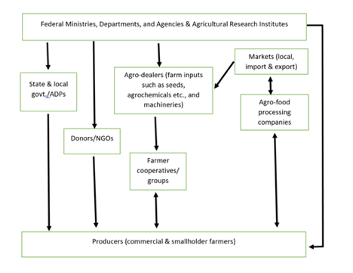
Key players in Nigeria's Agricultural & Agro-Food sectors.

Key advantages
factors that support growth and potentials of Nigeria’s agricultural sector


Population and human resources

Foreign investments

Technological advancement

Export potentials

Favourable landscape and climate

70% of households engage
in crop production
young and dynamic
demography
greater human capital and
work force
bases for economies of
scale and higher economic growth
huge employment
opportunities

Nigeria, among top 3 African countries that consistently received FDI FDIs contributes to improved technologies Funds technical expertise, practices & management Promotion of economic growth and development Creates higher wages and expanded employment Catalyst for growth and Nigeria's integration into global capital flows

Increased crop productivity and food production
improved seeds, plant varieties and pest control Reduced impact on natural ecosystems
Increased worker safety decreased use of water, fertilizer, and pesticides temperature-controlled shipping and humidifiers to prevent perishing
e-commerce to sell products
diversify from oil-based
economy which is threatened
contributes significantly to
positive GDP increase
allows for investment that
generates higher returns
opens up penetration of a new
potentially high-value market
favorable climate
conditions,
abundance of arable land
abundant water resources,
diverse agroecological and vegetation zones allowing
for various planting options

Major challenges
factors that currently impedes optimization of Nigeria’s agricultural sector


Socio-Political complexities

Financial Challenges

Infrastructural deficiencies

Environmental challenges.

Insecurity

Policies somersault
lack of qualified personnel investment climate is improving slowly standard and compliances - rejection of Nigeria food abroad due to, traceability, no- uniformity, certification
lack of agro- focused financing system Devaluation and instability of local currency (naira) Collaterals system for loans
Poor risk insurance system
absence of food storage and processing structures especially around food markets and farms
poor infrastructures (livestock building, warehouses, road)
regular flooding desertification environmental degradation (deforestation, poor, irrigation, low soil fertility and need for fertilizers water and air pollution from chemical
misconceptions about land use and right
herdsmen and local farmers conflicts violent clashes insurgencies destruction of amenities and improper maintenance culture
irregular policies Change in government priorities instability in fuel prices
Influence of diplomatic community Subsidy impact: fertilizers, fuel, etc.

